MAKEREREUNIVERSITY
COLLEGE OF COMPUTING AND INFORMATION SCIENCES

BACHELOR OF INFORMATION SYSTEMS AND TECHNOLOGY
GROUP 3 Entrepreneurship course work

YEAR II, SEM I
KYAMAYWA REGAN RONALD | 21/U/11649/PS
GABANGULA ISSA | 21/U/3885
EKIYASIIMIRE BELIEVE | 21/U/0908
KAYAGA BENITOR MUKISA | 21/U/13699/PS
KARUNGA ANGEL | 21/U/04687/PS
9/11/2022
Explain the major steps in the entrepreneurial process.
Entrepreneurship process is a course of action that involves all functions, activities and actions associated with identifying and evaluating perceived opportunities and the bringing together of resources necessary for the successful formation of a new firm to pursue and seize the said opportunities.
Illustration
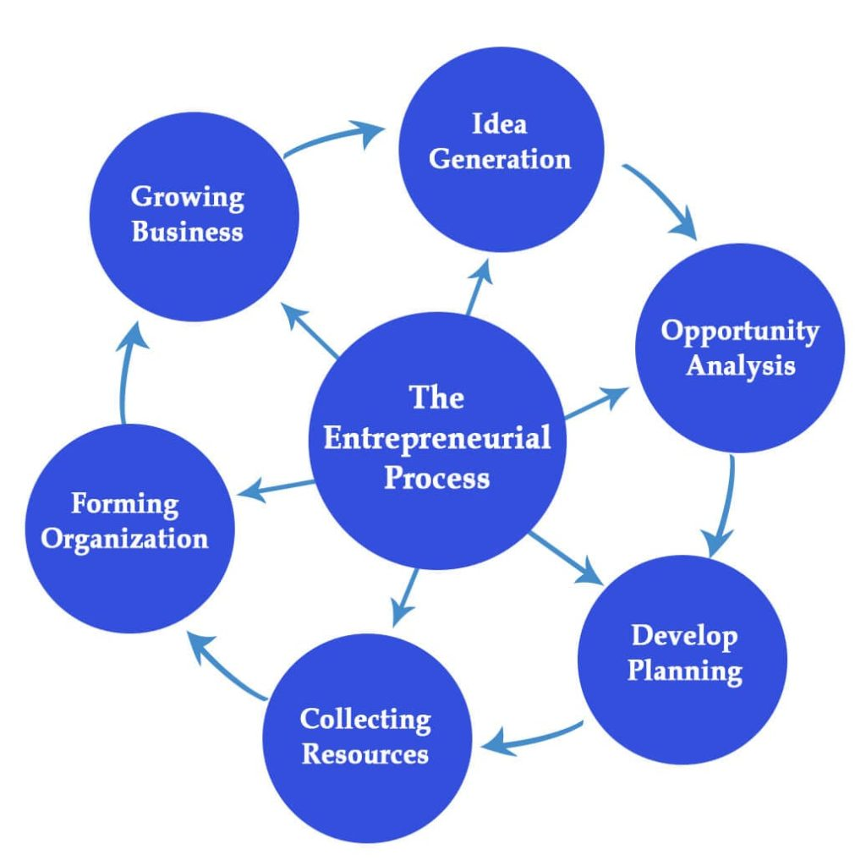
Idea Generation
This is the first step in the entrepreneurial process. An idea can be a problem or solution. Here, the entrepreneur identified an idea worth pursuing. The entrepreneur will conduct the feasibility study and take input from other stakeholders.

Opportunity Analysis
After identifying the opportunity, the entrepreneur will evaluate it. They will see if the opportunity provides any value to the business or the consumer, whether it will be sustainable in the long term if the profit is healthy, the market competition, the risks associated with the opportunity, and the entrepreneur’s product or service will be different or better than the competition.
The entrepreneur focuses on the following at the stage,
Is the opportunity worth investing capital, resources, and energy?
Can we offer better solutions than existing ones?
Can we beat the competition?
Is the business sustainable in the long run?
What are the risks?
If the answers are generally positive, entrepreneurs move to the next step.
Develop Planning
After analyzing the opportunity, the entrepreneur develops a plan to realize it and launch the company. This is a crucial step in the entrepreneurial process. The plan will have a business strategy and operating structures, including steps for the formation of the company. It will provide details on business objectives, goals, mission statement, and details of products or services.
Collecting Resources
Launching a new business requires resources, including financing, human labor, materials, and more. If the entrepreneur is self-sufficient, they can self-finance. However, they may go to investors or financial institutions to get the funds.
These days, entrepreneurs have a new option called crowdfunding. Using these platforms, entrepreneurs raise awareness about their business and ask for support.
If the idea resonates with the audience, businesses can quickly raise a significant amount.

Forming Organization
Once the entrepreneur secures the funds and resources, they will launch the company and form a legal entity. The structure of the organization will depend on its requirements.
The entrepreneur will name the company and file the papers with the government to form LLC, WLL or Public Limited Company(PLC), Corporation, or a Non-profit.

Growing Business
After launching the company, it will start producing products or offering services. The entrepreneur will ensure that the business is running smoothly and growing. Now the operating plan will be executed. The entrepreneur will have regular status updates and compare the actual progress with the planned progress. If things are not going as planned, they will take corrective actions to bring the progress on track.

Question b
b) What is an opportunity? differentiate between an opportunity and idea.
An opportunity
An opportunity is an identified chance that can be turned into a profitable business
I can be a prospect of establishing a business venture given the gap in satisfying the needs of a particular group of individuals.

It’s at a point at which identifiable consumers’ demand meets the feasibility of satisfying the requested product or service. I can be an idea that can be implemented, for which resources are available that will prosper.
A business opportunity has the following characteristics
It should be on a real demand i.e. should satisfy the needs and the requirements of the customers
I should be competitive i.e. should be equal to or better than the available products
Has to be acceptable in the community i.e. should confirm the social norms and be liked by the community for example a bar business could not be viable in a moslem dominated community
I should meet favor from the government policy of investments e.g. tax holiday
It should meet the entrepreneur’s objectives and goals.

An opportunity is an identified chance that can be identified into a profitable business
Whereas,
An idea is a response of a person or an organization to solve an identified problem or meet the needs in the community.

An idea
When an organization or person generates a business idea: -
It will help to respond to the market needs, because successful business has the ability to satisfy the needs and wants of the customers
It will help to exploit technology to do things better because technology has become the major tool in today’s market
It will help an entrepreneur to respond to natural resources
It will help an entrepreneur to introduce new fashions in the market
Business ideas can be got from the following sources
  - Newspapers
  - Magazine articles
  - Trade shows and exhibitions
  - Brain storming
  - Hobbies i.e. one may be able to expand his hobby into a profitable business as one enjoys doing it most.

In business, an opportunity is a key to success, without it a business cannot begin, expand or succeed.
The following are the roles of Business opportunity in entrepreneurial process;
The main purpose of an opportunity in the entrepreneurial process is to serve as the basis for any action that results in profit and business growth
Opportunities allow businesses to create and implement ideas and innovations and improve their performance.
To provide customer relationships. Good business opportunity bridges the gap between the entrepreneur and the customer
To bring dynamics of economic development in the society stems from the actions of the entrepreneur starting new business ventures or make existing firms grow

c) EXAMPLES OF POTENTIAL BUSINESS OPPOTURNITIES
Franchising. This is one of the most commonly found business opportunities in the industry. with franchising, the business plan and road map will be prepared ahead of time.
Marketing. Here, the focus is on network marketers who put together plans that can be used to recruit fellow marketers and as a result, a huge pyramid of marketers is created. In this, network, products, services and ideas can be sold.
Takeaway. This business opportunity in entrepreneurship aims at providing long-term partnerships and revenues. These opportunities include; management and negotiation skills.
Distributorships. A distributorship involves entering into an agreement to offer and sell the products of another without being entitled to use the manufacturer’s trade name. depending on the agreement, the distributor may be limited to selling only that company’s goods or may have the freedom to the market several different product lines
Drop shipping business. This is one of the best at-home business opportunities that lets you buy products directly from a supplier or manufacturer and ship them to customers.
Consulting. Consulting is one of the most common business opportunities that help a broader range of people with a specific skill for example Facebook Ads expert who educates business people on how to run effective Facebook ads.
Freelancing. In freelancing, you practice your skill for the business. Freelancing is an ideal business opportunity to pursue from home as it often entails remote work such as writing, graphic design, photography among others
Blogging. This is popular because it gives you the opportunity to create many potential sources of income. Bloggers often make money from affiliate marketing, ads, information products, physical products among others
Housekeeping business. These include housekeepers and cleaners which are hired by people in major cities to keep their homes clean and tidy while they are at work
Direct selling. The practice involves selling products not generally available in retail stores directly to customers. with rising need for supplemental income, recruiting new members is easier
Customer support. Customer service is a service that many companies require. You can start your own business-like customer service, managing other companies’ issues with customers via phone, email or chat.
Digital products. E-learning is exploding as an industry, making digital products one of the best online business opportunities for creators and educators alike. They can be held or touched but are popular amongst customers because they can download them and consume on their own time.

- Describe the three generic approaches for identifying opportunities.
There are three main generic strategies or approaches that a company could use to identify opportunities and gain competitive advantage in an organization. These include; Cost leadership, Differentiation and Focus. These generic approaches were developed by Michael Porter, an American academic known for his theories on economics, business strategies and social causes.
Cost Leadership Approach.
This involves minimizing the costs incurred in the business in terms of providing value i.e. products and services to customers. Cost leadership uses large scale production, cuts costs and uses economies of scale.
NB: Economies of scale refer to proportionate savings in costs gained by an increased level of production.
The main aim of cost leadership is to exploit scale of production, well developed scope and other economies for example a good purchasing approach and producing highly standardized products using advanced technology.
Walmart is a good example of companies that have successfully employed cost leadership strategy. The company has cut its costs and excesses at every point of production and thus able to produce quality products to consumers at low prices. Another example is the McDonalds.
The advantages of cost leadership include;
- It provides better profits for the organization. This is because the styles of cost leadership are focused on creating low –cost operations within their market and industry. Hence higher profit margins because of reducing development and production costs.
- It can increase an organization’s market share. This is backed by the customers’ preference and adoption of budget balancing between the need for the cost and the need for value. If goods are at the lowest cost but with the acceptable value, then the items are considered for purchase first. Therefore, these will induce more business, even out of a mature market.
- It improves the sustainability of the business. If costs of a business are low, then there are fewer financial threats that could put the organization out of business. For example, when trade wars happen in the local economy, it is the companies with the lowest cost of doing business that will have the greatest chance of survival because low costs become more sustainable with time hence a tremendous advantage.

The disadvantages are;
- It reduces product innovation. This is in a way that the cost leadership styles advocate Research and Development as extraneous costs. Therefore, they are cuts that tend to always happen in cost leadership and so fewer chances of innovation. It encourages the same products to be sold at lower prices only.
- It limits the importance of consumer feedback. Leaders usually become very focused on the price of goods and services being offered and so easily ignore how the market shifts over time.
- It requires a large volume of sales to be successful. This is because the lower the costs of production, the more resources required for high incomes, therefore for successful cost leadership, there have to be large volumes of sale in order to maintain the overall profitability.
- It disregards the time and purpose of market research. This means there is no time created for innovation and creativity in the market since the same products are being sold at low prices so the community will respond to what is being offered.
Differentiation Approach.
This strategy involves nothing but an approach that pushes organizations to develop unique features for their products and services as compared to their competitors. The main goal of differentiation is to gain a competitive edge and earn greater reputation in the target market. To accomplish this, the organization or business must know its strengths, weaknesses and customer preferences or needs.
Examples of companies that have successfully taken on this strategy include Apple which has achieved this through innovation and product design. Furthermore, a unique operating system that makes them stand out. Amazon an ecommerce giant that is at the top of everyone’s list when you need something. They are different in a way that they sell literally everything at the lowest prices possible and with terribly fast services.
Advantage
- Reduced price competition. This is because differentiation helps companies to lower their price commission in the industry. For example, a firm like apple producing quality phones, there competitors will struggle to succeed even after dropping their prices. When people receive quality, they do not mind paying higher prices.
- Product uniqueness. As the strategy suggests, when companies opt for it, they achieve success because their competitors cannot deliver the same quality and features of their product. So this makes them one of a kind.
- Increased profit margins. A company whose product is high quality and unique can set higher price points, therefore resulting in increased profits and large sums of income. The company in turn can earn higher revenue with maximum sales.
- Customer loyalty. Differentiation gives room for innovation through research and so companies are able to remain empathetic towards their customers by creating products they require. This in turn results into brand loyalty and customer satisfaction.
Disadvantages
- It can strain the resources. This is because differentiation can be demanding in terms of time, energy and resources will be spent to develop a product that is incomparable and sets itself apart from competition.
- Challenge of changing the customer perception. Most customers perceive any product as equivalent to alternative products offered in the market price at a lower price. This limits the market for the differentiated goods.
Focus Approach.
This is a method of developing, marketing and selling products to a niche market, which could be a type of customer, product line or geographical area. A niche market is a segment of the market on which a specific product is focused, is defined by its own needs and preferences. For example, Shoes for Vegan women or men. The main aim of the focus strategy is to exploit undeserved or undiscovered segments of a target market.
Focus Approach is divided into two i.e. Cost focus and differentiation focus. Where the Cost focus involves a firm seeking a cost advantage in its target segment while the differentiation focus involves a firm seeking to outperform its rivals through offering unique products for its target segment.
Advantages
- It helps to build strong relationships with each target market. This is because the focus strategy enables specific targets or customers who later become consistent on the products they purchase from a particular supplier.
- It brings expertise into the products or services. Product knowledge is an asset that cannot be ignored. To create the best possible product for a targeted demographic, it has to be backed by some expertise, this expertise creates a barrier to entry within the market to competitors.
- It may limit the competition. When a focus strategy is created, the company most times is looking for natural ways to limit competition. Therefore, it becomes difficult for others to copy or duplicate your product since you are like the best at what you do within a specific niche.
Disadvantages
- It may limit the initial demand of a product or service. The number of sales generated within the market is decreased when you are working on something that is very specific. This may be backed with the fact that the reputation of the brand may not be as strong to attract enough attention to it with time.
- It offers lower equipment utilization rates. This is because a few resources are required to produce the product for the targeted market, so the rest of the resources are being wasted and less focus on planning and controlling production, also, it becomes more difficult to deal with personal scheduling or even managing inventory.
e) QN: Discuss the process of opportunity recognition.
Opportunity recognition is a process when individuals and organization actively seek out as well as perceive, opportunities for new products and services.
OR: Is a step by step procedures of how an entrepreneurship identifies an opportunity and makes it a viable business idea.
The following is the opportunity recognition process;
a) Getting the idea; The first stage is for the entrepreneur o get the business ideas. An individual can generate a business idea from a ninche in the market. A niche is a gap left unfulfilled by those currently serving the market. It provides a chance for other people to add value that was unmet. It allows the new entrepreneurs to perform differently and compete with already existing business.
b) Identifying the opportunity; Opportunity identification is when an individual realizes a business a business idea with good returns that has not been discovered. It requires keen scanning of the business environment, being alert about the changing information and the ability to use the information effectively.
c)Developing the opportunity; Developing an opportunity requires the entrepreneur to modify the idea to suit the current market needs. During this stage, research is conducted to identify whether the business idea can be converted into an actual business.
D) Evaluating the opportunity; Opportunity evaluation is the stage where the potential risks are assessed. It is identified whether the risks will be worth the investments made. Profitability is also scrutinized to find out how long the payback period is after an investment.
e) Evaluating the team; The final stage involves having a skilled team to bring the business idea to realization. Employing capable people who will work to make the opportunity economically viable

References
https://openstax.org/books/entrepreneurship/pages/5-1-entrepreneurial-opportunity
Aidrich, H. (1999).Organisations Evolving, London:SAGE.
Micheal J Stahl;David W .Grisgby(1997). Starategic management. Blackwell Publishing. ISBN 978-1-55786-650-9
Gavin C Reid (1993) small business Enterprise :An economic Analysis Published by Routledge .ISBN 978-0-415-05681-6
“Wal-Mart’s Cost Leadership Strategy”

